RESULTS
The Fig.6 shows the underwater image suffers from poor quality due scattering effects, illumination conditions etc. is taken as the input image.
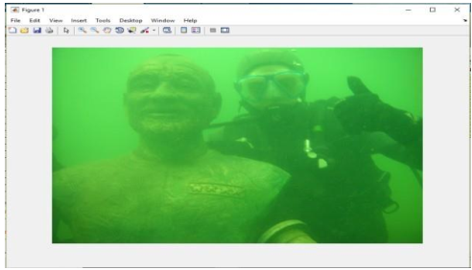
Fig 5.1.Input Raw image
The fig.7 shows the gray scaled version of input raw image.
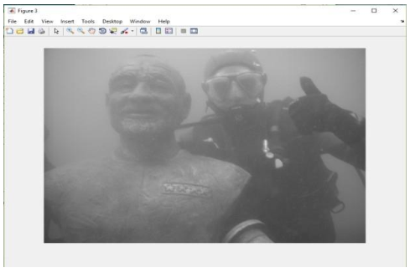
Fig.5.2. Grayscale Image
Fig. 8. Shows the image after removing the unwanted color casts which occurred due to scattering effects of light underwater.
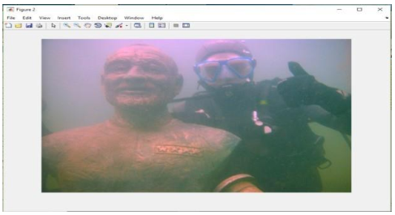
Fig.5.3.White Balanced Image
Fig.9. shows the improved quality image after applying the BEMD technique.
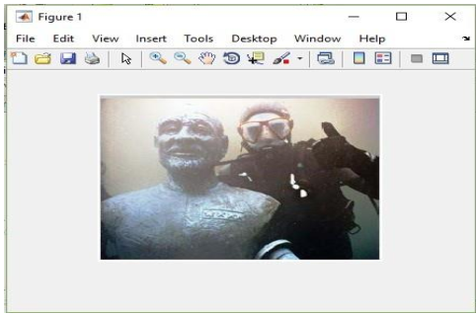
Fig.5.4. Image after BEMD
Even many images we tested and got results with removed unwanted content.

